
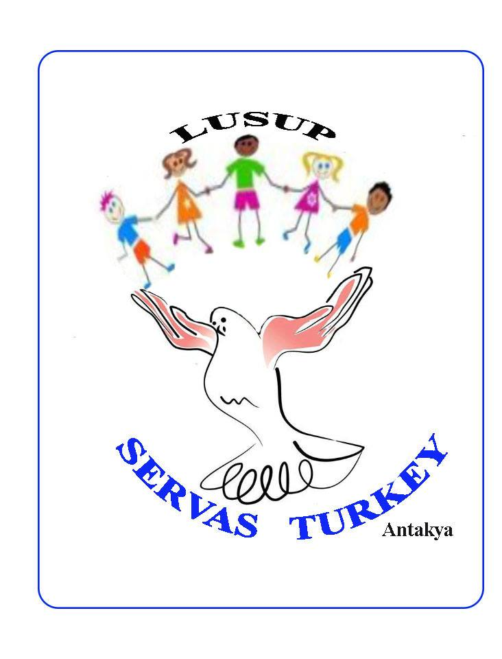
8th Live with Us Share with us (PEACE SCHOOL) FORM
July 06-16th, 2016
Personal Info.
Name/Age/Gender:
Profession:
e-mail/tel:

DATES YOU STAY (Min. 5 days)
ACTIVITIES

AIMS
MATERIALS&TOOLS
(bring your own materials if possible)
AGE GROUP
DURATION
SPACE NEEDED
NOTE: Please bring as many things (photos, maps, flags, music, videos, candies, etc.) as you can related to your culture/country/town/family, etc.
Deadline for application: June 1st, 2016
Mehmet ATEŞ
Coordinator
mehmettates@yahoo.com
Antakya, TURKEY

