SIPR 2018 (Servas International Peace Riding) along the Han River.

- When : Oct. 21st. ~ Oct. 24th. 2018 (3 nights & 4 days).
- Where : From International Youth Center Youth Hostel (Venue of SICOGA 2018)
to ChunCheon-city.
- Distance : 300Km. (Bike Riding 188Km + Train 112Km)
- Estimated Participants : 40 riders over 10 Countries.

Servas Korea would like to invite you to the SIPR 2018 Bike Tour on Oct. 21st- 24th. 2018
after SICOGA 2018.
We are promoting an experience of ‘Peace Riding’ to share the values of peace and enjoy the beautiful scenery of Hang River focusing on the relationship with Servas members.
This SIPR 2018 bike tour is opened to all Servas members who love bike tours and enjoy the sights and feeling of the natural environment which has been preserved to protect Korea’s exceptional beauty.
Let’s share great experiences together in wonderful Korea, Let’s meet up with SIPR 2018 bike tour !!
This trip’s route is from International Youth Center Youth Hostel (Venue of SICOGA 2018) to ChunCheon-city covering a distance of approximately 300 kilometers.
We will ride a bike along 40~50Km per day and will use trains for some distance.
Cycling along the GyeongChun Course -- dramatic scenery along a picturesque mountains and breathtaking views.

Contacts :
- Mr. DW Song (dongwhany@gmail.com)
- Mr. BW Choi/Servas Korea National Secretary (bwchoi1211@hanmail.net)

BIKE TOUR PROGRAM

Day 1 : Sunday, Oct. 21th, 2018
: Total 72Km (45Km/Riding + 27Km/Train)
10:00 Depart at International Youth Center Youth Hostel (Venue of SICOGA 2018)
Hangang park Seoul Forest tour by bicycle Jamsil park
Take a train at Eungbong station to Paldang station Dasan Guest House
Day 2 : Monday, Oct. 22th, 2018
: Total 58km (Riding)
07:00 – 08:00 : Breakfast
Dasan Guest House DaesungRi Recreation Area Nami Island tour JaraSum tour
Gapyeong Guest House

Day 3 : Tuesday, Oct. 23th, 2018
: Total 43km (Riding)
07:00 – 08:00 : Breakfast
Gapyeong Guest House Gugok Falls tour Uiam Dam Sky Walk Ethiopia
memorial hall for Korean war ChunCheon Guest House

Day 4 : Wednesday, Oct. 24th, 2018
: Total 127Km (42Km/Riding + 85Km/Train)
07:00 – 08:00 : Breakfast
ChunCheon Guest House Chuncheon Culture center Uiam Dam tour
Take a train at ChunCheon station to GongDeok station International Youth Center
Youth Hostel (Venue of SICOGA 2018)
14:00 Farewell Party
Full Route for SIPR 2018

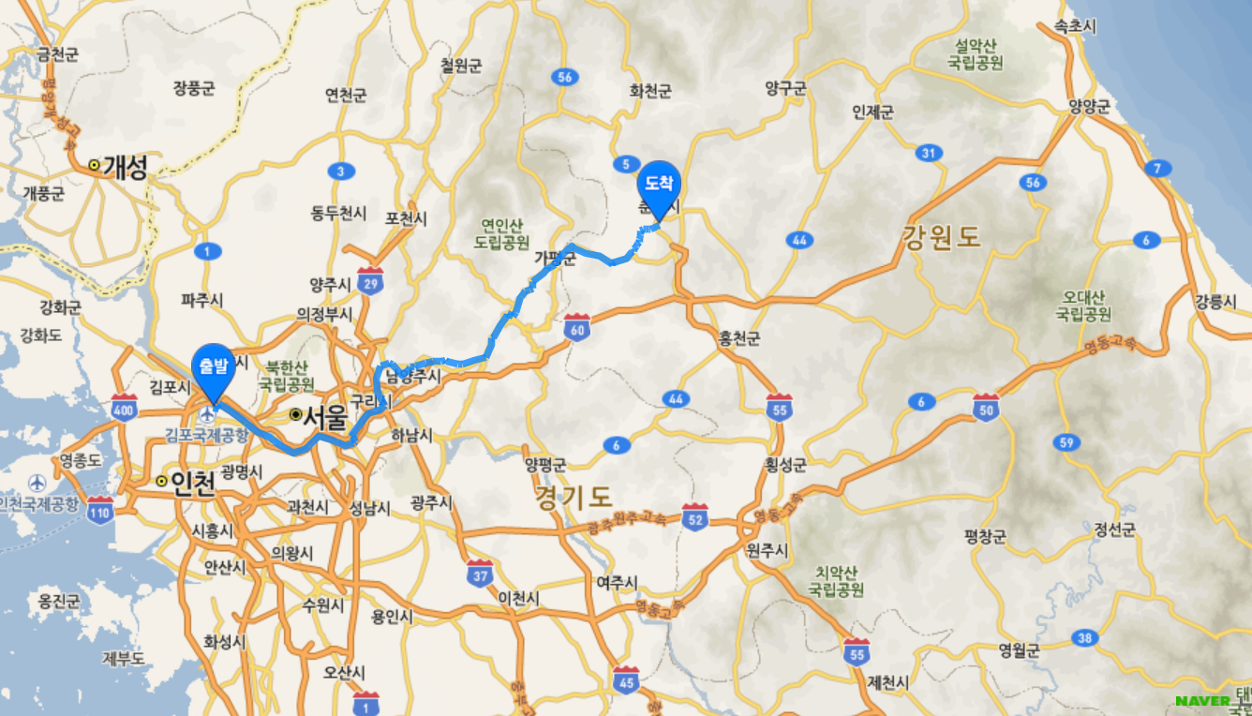

## Riders need to bring own bike and safety gears.(or can lease bikes and gears in Seoul)

FURTHER DETAILS :

- Participants : 40 Riders.

- If you are not coming with your own bike : the bike rental costs is USD 10/day. Please specify in the Registration form.

Registration costs (fee):
The fee is USD250 (3 night 4 days) and it has to be paid before the meeting with your payment for SICOGA 2018. Your registration will be valid and confirmed only after payment receipt.

Bank Details
Bank Name : KookMin Bank
Bank Add. : 5th FL KookMin bldg. 84 Namdaemun-Ro, Jung-Gu, Seoul, Korea
Account No. : 410702-04-213962
Account Name : Lee JaeKyung (Servas Korea)
Swift code: CZNBKRSE
Fee includes:
- Breakfast, Lunch and Dinners
- Accommodation (Youth Hostel or Group accommodation in common)
- Support Car
- Train fee, Entrance ticket fee

Fee does not include:
- Bike rental (USD10/day)
- Personal insurance
- Accommodation on Oct. 20th – We can arrange International Youth Center Youth Hostel (Venue of SICOGA 2018) for you on request.

Pre-registration form for SIPR 2018

Please complete this form and send it by July 31st, 2018 when you register SICOGA 2018 to Mr. DW Song (dongwhany@gmail.com)

Name and Family Name: ____________________________________________________

Address (street, city, country): _______________________________________________

Phone (include Country code number) Mobile ________________ Home _____________

E mail ______________________________________

Please contact me by… (put an X on the box/boxes) : ( ) Phone ( )E mail

Plan & Accomodation:

( ) Attend SICOGA 2018 Conference and SIPR 2018 Bike tour

( ) Attend only SIPR 2018 Bike tour

( ) After the SIPR 2018 Bike tour, I ask Servas hospitality:
□ yes, (specify which town) _____________
□ I do not need Servas accommodation (I’ll manage it by myself)

Bike Rental :

If you need to hire a bike, we’ll manage it for you.
In this case, please indicate your height (cm):_____ We will find the bike that suits you better.

Now please check with an “X” one option:
( ) I’m joining the meeting bringing with my own bike
( ) I need to hire a bike
DECLARATION

(Please sign this declaration, print this paper and take a copy with you at the meeting)

The "SIPR 2018” organized by Servas Korea is intended as a meeting between friends. The organizers are all volunteers, which means they are neither guides nor professional tour operators. Each participant is therefore responsible for his/her own safety, and is responsible for any damages caused to her/himself or to third parties. A personal insurance is recommended. Helmet is mandatory.

(Please put an “X” in the box below)

( ) I declare to participate to " SIPR 2018" under my responsibility and I am aware that the organizers and the SERVAS organization does not have any liability-responsibility for any damage or inconvenience that I might cause to others -things or persons- and to myself.

Signature ________________________ date:____________/2018

Good! Thanks for completing this form. Now please send a mail to the organizers (dongwhany@gmail.com) and don’t forget to attach this form .
Remember to print one copy, sign it and bring it with you at the meeting.
Thanks and see you !!

For further information, feel free to contact the organizers:

- Mr. DW Song (dongwhany@gmail.com) C.P (+82) 10 3787 5691
- Mr. BW Choi (bwchoi1211@hanmail.net) C.P. (+82) 10 5255 0591

